Covid
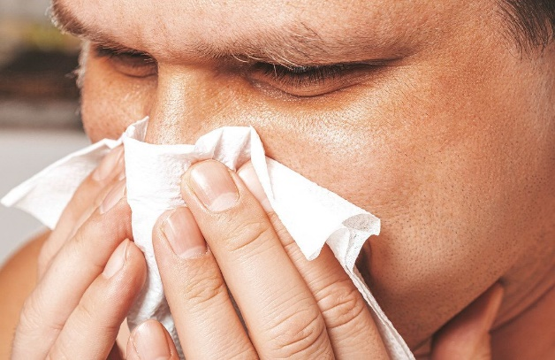
This Photo by Unknown Author is licensed under CC BY

If you have any symptoms of Omicron,
runny nose
headache
tiredness
sneezing
sore throat
please do not come to the hall but stay at home until you are free of symptoms.

Please wear a mask if you are in a crowded area and use the sanitiser to keep your hands clean.

KEEP THE HALL WELL VENTILATED

